**Chapter 10 – Conics Project**

Summary: Instead of a written exam for Chapter 10, you will create and analyze a picture, composed of at least 8 conic sections.

Step 1 – Intro to Desmos:

Go to <https://www.desmos.com/calculator>. Create an account. Use your ISQ student email address.

Create and save a file called “playing around”. You ***must*** try each of the following. Mr. Malan may ask to see your file as proof that you tried these.

|  |  |  |
| --- | --- | --- |
| **Skill** | **How to Experiment** | **Notes/Thoughts** |
| Basic equation | On left, type y = x^2 – 3 It will format the exponent for you. |  |
| Shading | Start with .  Then change the “” to these:  Then try the same with other conics  Then try | To type , first type “<” and then “ = ” |
| Stretch/Compress  Shift | Start with  Then play with the denominators  Then replace with | Yes, those denominators could be written as 4 and 12.25, but I will require the “squared” format in this project. |
| Restricting or values  Use { } | Try  Where is it? Could you do the same thing with an “ restriction”?  Suppose you want to draw someone wearing a bow tie. Try:  🡪 then add: on the same line.  Note: it is possible to use more than one “{ }” restriction on a line. |  |
| Multiple Restrictions | Start with  At the end of that line, add a restriction {y<10} Then add another: {y<10}{x>-2}  These two restrictions tell Desmos that it should only shake where both restrictions are obeyed  Challenge: Add a third restriction, specifying that the shading should only be OUTSIDE of | For another interesting restriction, check out the green oval on page 4. |
| Change Line Style | Graph , then click and hold the  button to select your line style and color. | Sometimes, it doesn’t work on the first try. |
| Some Functions from Other Chapters | Try:    * 🡪 it should give you “” * 🡪 what does it give?  (notice you can click on the index and change it) * can also be written as | For absolute value, use the button above the “Enter” key. |
| Sliders | Type  When it says, “add slider,”, click on | Note: Your final project may **NOT** contain sliders. They are just for helping you make adjustments. |
| Pictures | On top left, click on “**+**” and notice that you can add a picture.  Your project may include one picture, if you wish. | (Just for fun; No bonus) |
| Just checking… | Did you read the instructions about making an account and saving these steps in a file? If not, do it now. I have had students put in hours of work on their actual project without saving their work and then lose it all. Get in the habit of making a file for any work you do and saving often. |  |
| Folders | On top left, click on “**+**” and click on “Folder”  This can be a nice way to organize your work  (For example, if you draw a face, you may wish to have all your “teeth” equations together and all your “eyes” equations together.) |  |
| Check out the extra credit instructions | Optional. See below. |  |

|  |
| --- |
| Extra Credit: “Higher Even Powers”  ***In addition to the 8 required conics***, you may include 2 different relations that are based on conic equations. This will happen by replacing the “square” exponents with ***higher even exponents***.  For example, start with , but then change it to . What happens? Then try 6th powers. Then 16th powers. What happens? Now try changing the (+) to a (–).  Look for a way to incorporate these new shapes artistically. This exponent adjustment method works on all four of the original conics.   * One shape with a higher power 🡪 +1 bonus point * Another shape based on a ***different*** conic  with a ***different*** higher even power 🡪 +1 more bonus point. (Maximum 2 points total) |

Step 2 – Close the website. Sketch by hand:

What picture do you want to make? Flower? Zombie? Super hero? Bird? Get creative! It must be a recognizable picture and not simply be a random collection of circles, parabolas, etc. Your sketch (and final product) must include:

* At least one conic from each family: circle, ellipse, hyperbola, parabola.
* 4 ***additional*** conic sections. These may all be from the same family if you wish. In total, you will have at least 8 conic sections. Feel free to use more, if it will help your picture!
* One or more shaded sections.
* One “strict” inequality (such as “” as opposed to “”) yielding a dotted line boundary. Simply using the dotted line function  will not receive credit.
* Two non-conic functions from previous chapters. Examples: lines, absolute value, cubic, cube root, exponential, logarithmic, ~~rational~~ (not Sp2020), polynomial, etc. Lines of the form constant or constant **do not count.**
* Shifts: *Only two* of your eight conics may be centered at .

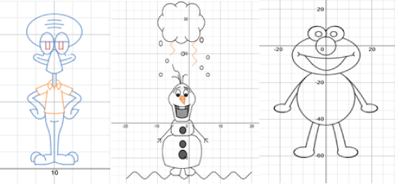

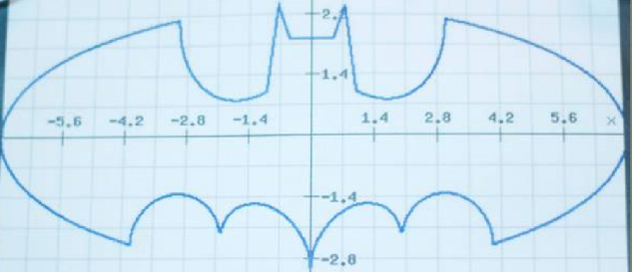Think simply! Here

are some students  
who got a little

too carried away ☺

Step 3 – Get Approved:

Once you have an idea, sketch it on the first page of your work pack. Then answer the questions about plagiarism. Show it to Mr. Malan for approval. (He has a name check-off list.) Clearly label your 8 conics. You can simply write C/E/H/P next to each **C**ircle, **E**llipse, **H**yperbola, and **P**arabola. Label your two non-conic functions.

If you wish to try the extra credit, show how it will be used artistically.

Then answer the five plagiarism questions and bring your paper to Mr. Malan. Once he approves it, you will be ready to start

HBL: Upload a sketch of your proposal on Moodle. Please take a clear picture. Somewhere on the picture, include answers (A/B) to the five plagiarism questions.

Step 4 – Build it!

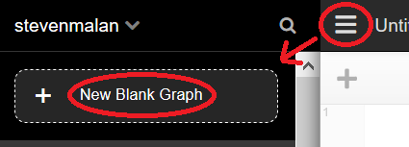Log in to your Desmos account. Start a “New Blank Graph” and save it with an appropriate name (“Spaceship,” “Barbie,” etc.). Build your shape. Save often (Ctrl S or the “Save” button).

All conics must be graphed in **standard form**. So set each one up in standard form, and then play with , , , , and to move and stretch it.

(So is **not okay**, but **is okay**, even though they are the same equation.)

Note: When getting ellipses and hyperbolas fitted just right, maintain exponential notation in denominators. For example, instead of typing , type . If you need to stretch it a little in the direction, try changing the 6 to 6.05 (instead of changing the 36 to 36.5). Then when you have to do calculations by hand, this will save you from (some) annoying square roots.

Note: Sliders are great for getting everything centered just right, **but may not be included in your final product.**

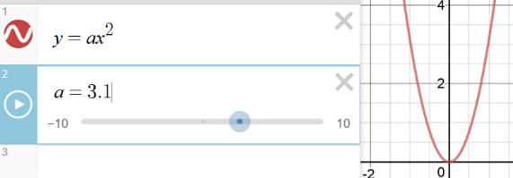

So, if you use to get your parabola just right and find this:

You should then delete the and replace it with 3.1.

(-1pt for each slider left in final the product.)

Use colors thoughtfully to make it look nice. Simply having color is not enough. (Desmos does this automatically.) You should ***use*** colors artistically, in a way that will add to your picture.

If you would like to insert a fun picture, you may do so. It will not increase your grade at all. Only one picture is allowed per project.

Note: A picture should ***not*** be used as an elaborate stencil. For example, a student wanting to draw Northern Vietnam should not insert an image and then tediously fit hundreds of lines to trace the border (shown in red below). This really misses the whole point of the project ☹

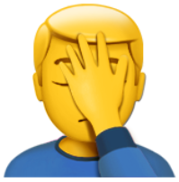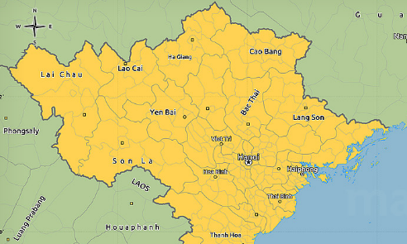 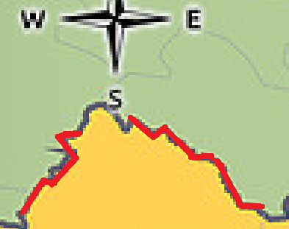

To use a picture for ***a little bit*** of guidance, get Mr. Malan’s approval first. The circles/ellipses/hyperbolas/parabolas should be the real heroes of the project.

You should only use equations that we have done in class, or which you get approved. I do not want anything like this: *(from a student submission in a previous year)*

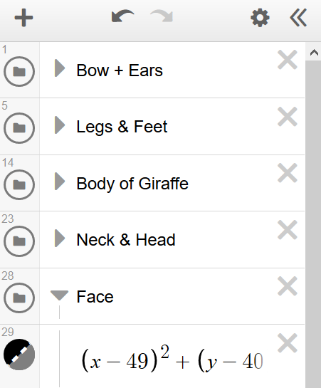Suggestion: It is possible to sort your equations into folders. Check out what this student did while creating a giraffe (2016-2017).

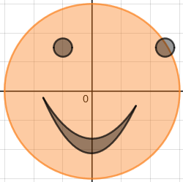

Things should line up reasonably well. For example, if you’re making a happy face…

- The lopsided smile would not lose any points (left side is higher)

- The misplaced eyeball ***WOULD*** lose points.

Plagiarism – This project counts as an exam grade. If you plagiarize, you will get an automatic zero on the whole assignment, along with a detention and possible further consequences. Your project will be checked against all other students (past and present) and against online examples. Also, remember what the [ISQ Secondary Handbook](https://isqchina.com/en/images/ENG%2019-20%20SEC%20Handbook%20August%2019.pdf) says: “A student who assists another to cheat will also receive a zero.” (pg. 20).

Step 5 – Decompose by Hand (50 points):

***From your picture***, pick one shape from each conic family. For each conic, find the appropriate page, write the equation along with its Desmos equation number (so Mr. Malan can find it easily). You should treat all relations as basic equations, ignoring any shading, dotted/solid distinction, and restricted domains.

So if you wish to decompose this from your picture: You should graph this by hand:

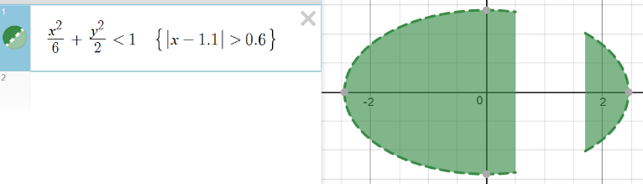 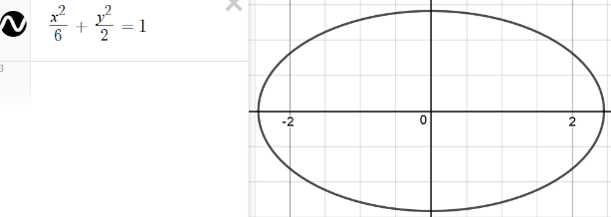

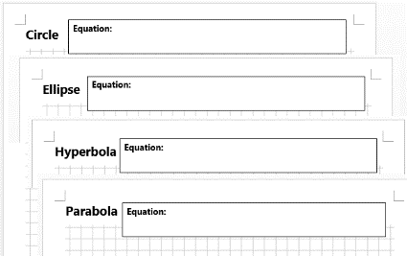Notice the “ = ” sign and how there are no brackets

To say it another way, these sections of your work should not have any inequalities or {curly}{brackets}

Then calculate each of the required elements and label them on your drawing. Show lots of work!

Give radical values in exact form ***and then use a calculator and give decimal approximations for all square root expressions.*** (So should be written as ).

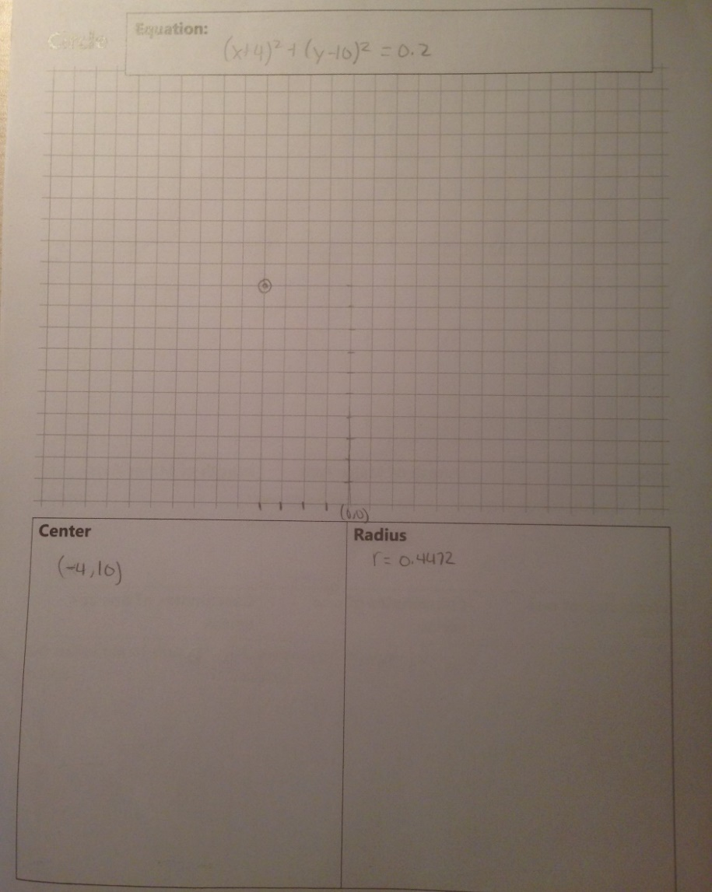Make your sketch useful. Feel free to fiddle with the and axes. Do not do what this student did.

Instead, he/she should have zoomed in on the section that he/she was graphing.

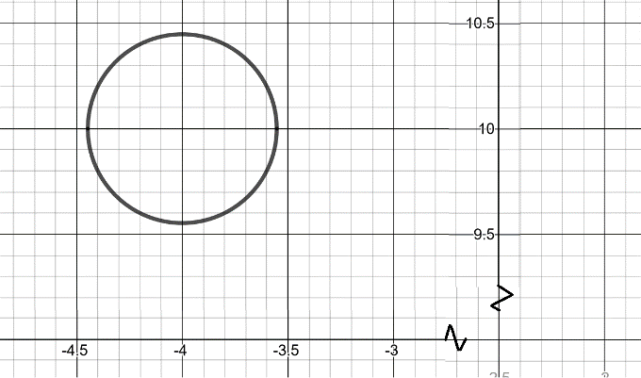

|  |  |  |
| --- | --- | --- |
| **Shape** | **Please calculate and label each of the following:** (accuracy counts!) | **Value in Overall Grade**  (2pts for each bullet point) |
| Circle | * Write standard form equation and graph the circle * Center * Radius | 6 points |
| Ellipse | * Write standard form equation and graph the ellipse * Center * Length of major axis * Length of minor axis * Coordinates of one focus * Coordinates of one vertex * Coordinates of one covertex | 14 points |
| Hyperbola | * Write standard form equation and sketch the hyperbola  (show the “box” and asymptotes) * Center * Length of transverse axis * Length of conjugate axis * Coordinates of one focus * Coordinates of one vertex | 12 points |
| Parabola | * Write standard form equation and sketch the parabola * Coordinates of vertex * Coordinates of focus * Equation of directrix | 8 points |
| Neatness and Labels | Good labels and scales, Followed general instructions, | 2 points |
| Short Reflection | On the back page, give thoughtful answers to the two reflection questions. | 3 points |
| Warning: for the four “Length” calculations above, remember to give the full length, and not just half. | | Total for hand-written portion:  45 Points |

Step 6 – How to Submit:

In Class: Turn in your hand-written packet (on which you decomposed four of your conics in Step 5).

Your final product will probably look a little different from your original sketch. That’s just fine!!   
(HBL: Since we will not be meeting in-person yet, you will submit photos on Moodle)

On Moodle: Upload a link for your Desmos graph on Moodle. See instructions here:

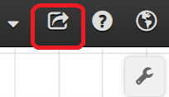 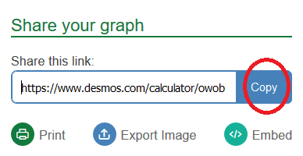 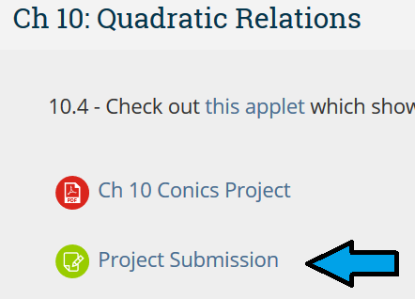

Click the “Share” button 🡪 Copy the link address 🡪 Submit Link on Moodle

You are responsible for making sure that you copy the link correctly, so try pasting it into a blank webpage first. If you submit a bad link, ***then you have not submitted your project!***

Do ***NOT*** simply use the email feature on Demos. (deduction)

The submission is due at the start of class (10:20:00 am) on the day it is due. Moodle will time-stamp your submission when you turn it in. If it is submitted 1 second too late, it will count as 1 day late. Please do not wait until the minute before class to submit, in case your internet goes out.

Display (Not for Extra Credit)

Your creation will be shown to the class. We will vote for the best ones and make them into posters. These will be displayed around school and possibly submitted for the Lighthouse (school newsletter).

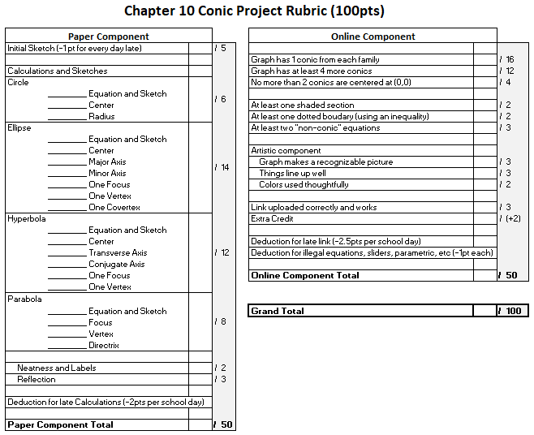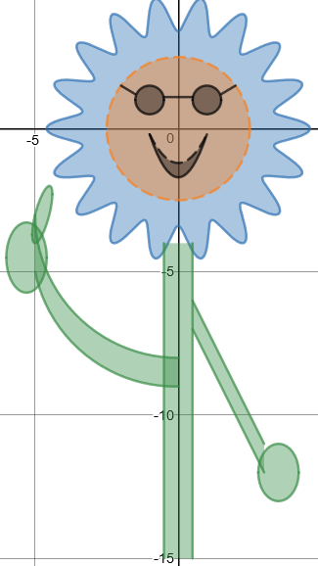

**加油！**